https://axminsterandlymecancersupport.co.uk/beach-hut/
Click here to book the Beach Hut
Then then takes you to EventBrite
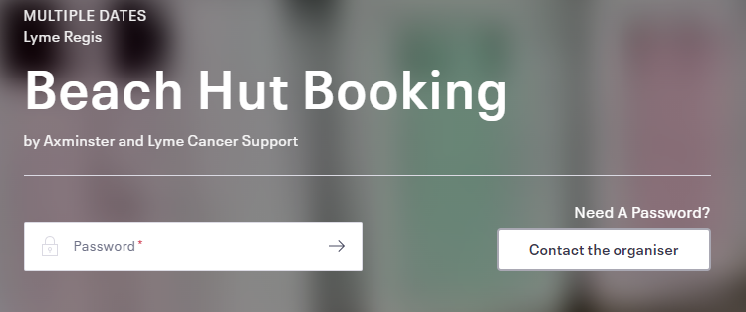
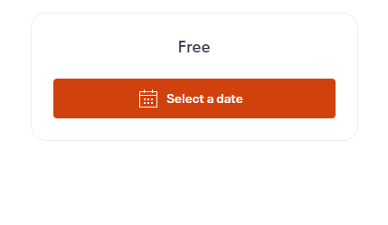
Enter the password provided in the email.
On the right-hand side click
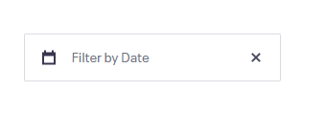
Click Filter by Date

Select the date you wish to book

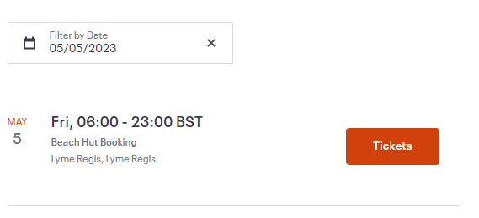
Complete the informaton and click Register again,

