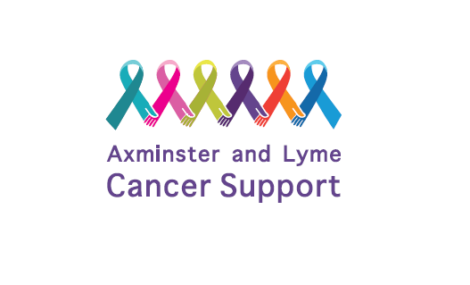
Date Received:
Re-Register Form

IN CONFIDENCE
Thank you for your interest in Axminster and Lyme Cancer Support. Please complete this form and return it to mary@axminsterandlymecancersupport.co.uk or by post to the address at the bottom of the form.
Date Diagnosed |  | *Date Finished Active Treatment

Name

Address
If any changes
Postcode
Home No. | Mobile No.
Email Address | Date of Birth

Emergency contact details
Name | Home No.
Email Address | Mobile No.

Please advise what treatment you are currently going through and any areas of support you would like.

⇨ 1-2-1 Volunteer Support* *Telephone support from an ALCS volunteer ⇨ Drop-in Monday’s 2-4pm

⇨ Active Treatment Support ⇨ Informal Men’s Events

⇨ Weekly Auricular Acupuncture Clinic ⇨ Creative Workshops

⇨ Referral for counselling, treatments or activities
(a list is available to choose who you feel would be most beneficial)

⇨ Beach Hut (available for hire on Lyme Regis Beach)

⇨ WhatsApp group chat ⇨ Jigsaw* ⇨ Related books* *Books & jigsaws from our library.

Signature |  | Date

We would like to be able to send you information about the services we offer and events at Axminster and Lyme Cancer Support. All information provided to us in this application will be in strictest confidence in accordance with current data protection legislation. A copy of our Privacy Policy is available on our website www.axminsterandlymecancersupport.co.uk. | Please tick here if you are happy for us to stay in touch with you and send appropriate mailings.  ☐ GDPR tick box

Are you happy for photographs to be taken at events and used in social media and marketing? | ☐ Yes ☐ No

We are committed to equality and diversity and work hard to provide a safe environment at our events. You can view our policies on the website or email info@axminsterandlymecancersupport.co.uk to request a copy.
Please note your data will not be used for marketing or fundraising purposes.

This form should be returned to:
Axminster and Lyme Cancer Support,
Cross Keys House
Chard Street
Axminster
EX13 5EB

*Active Treatment is classed as - Chemo/Surgery/Radiotherapy.

