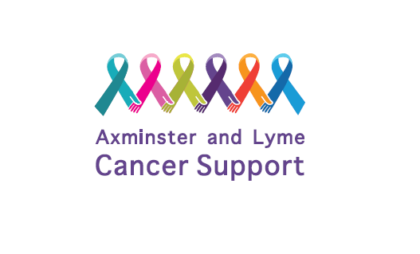
Date Received:
Registration Form

IN CONFIDENCE

Thank you for your interest in Axminster and Lyme Cancer Support. Please complete this form and return it to mary@axminsterandlymecancersupport.co.uk or by post to the address at the bottom of the form.

Personal details

Client ⇨ | Carer ⇨

Date Diagnosed |  | Date Finished Active Treatment

Name

Address

Postcode
Home No. | Mobile No.
Email Address | Date of Birth
Preferred method of communication
- Text
- WhatsApp
- Email
- Call Mobile
- Landline Telephone

Emergency contact details
Name | Home No.
Email Address | Mobile No.

Are you currently undergoing treatment for cancer? If yes, please give brief details of treatment and cancer, including your main hospital for treatment.

If you are a carer, please give details of who you are supporting with cancer, or any other ways you have been affected by cancer.

Please say how you heard about Axminster and Lyme Cancer Support.

Do you have any additional needs such as health conditions, disabilities, mobility issues, allergies that we should be aware of? If yes, please give details.

What support /help would make a difference?

⇨ Exercise (eg Aqua, Nordic Walking, Yoga etc) ⇨ Creative Workshops

⇨ Referral for counselling/treatments ⇨ WhatsApp group chat

⇨ Beach Hut (available for hire on Lyme Regis Beach) ⇨ Social Events

You can access all information via www.axminsterandlymecancersupport.co.uk or at Cross Keys House, Chard Street, Axminster, EX13 5EB.

We are open Mondays for Drop-in 10am – 4pm and other days by appointment.

Signature |  | Date

We would like to be able to send you information about the services we offer and events at Axminster and Lyme Cancer Support. All information provided to us in this application will be in strictest confidence in accordance with current data protection legislation. A copy of our Privacy Policy is available on our website www.axminsterandlymecancersupport.co.uk. | Please tick here if you are happy for us to stay in touch with you and send appropriate mailings.  ☐ GDPR tick box

Are you happy for photographs to be taken at events and used in social media and marketing? | ☐ Yes ☐ No

We are committed to equality and diversity and work hard to provide a safe environment at our events. You can view our policies on the website or email info@axminsterandlymecancersupport.co.uk to request a copy.
Please note your data will not be used for marketing or fundraising purposes.

This form should be returned to:
Axminster and Lyme Cancer Support,
Cross Keys House
Chard Street
Axminster
EX13 5EB

For Office Use Only

- DB
- PP
- WA
- BH
- ML

