Guide to creating a Local Giving fundraiser for Axminster and Lyme Cancer Support
Access ALCS Local Giving page at | https://localgiving.org/charity/axminster-and-lyme-cancer-support/
Select “fundraise for us” | 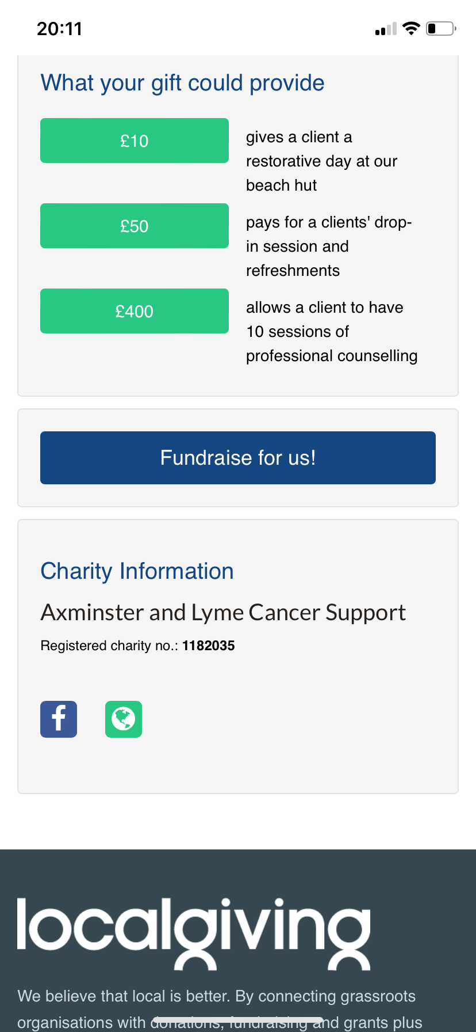
Select Axminster and Lyme Cancer Support as your charity and the type of activity you plan to do from the drop down lists  Choose a title for your fundraising page (top tip – not too long!) | 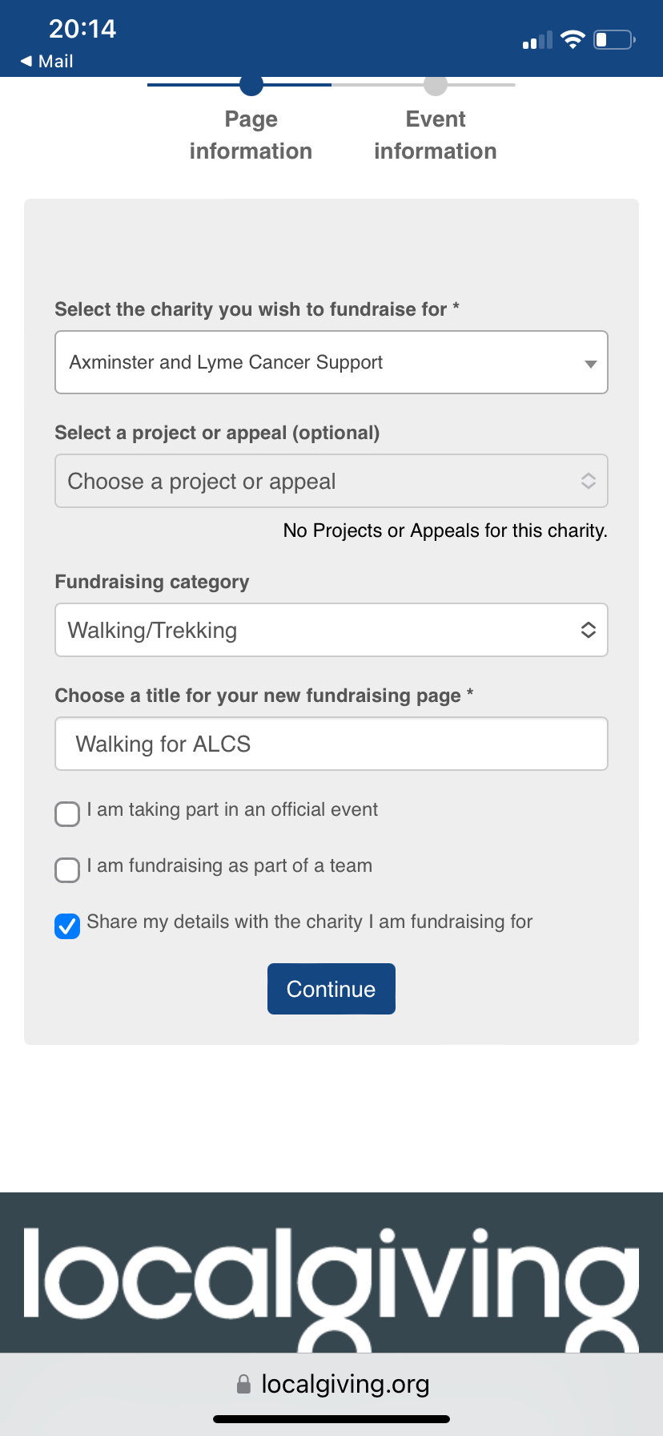
Now you can set up your fundraising page.  Either select an official event – or create your own fundraising page.  You will be invited to add a picture/photo. These help to identify you and your activity so please do so. | 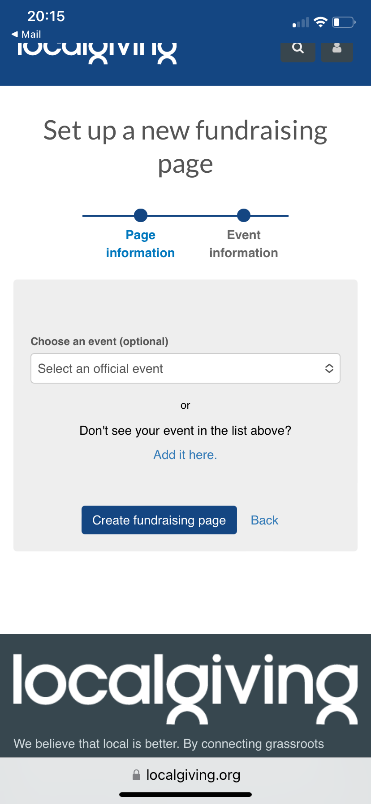
Create your URL  Important – keep it short and meaningful.  For example:  ALCSWALK  ALCSRUN | 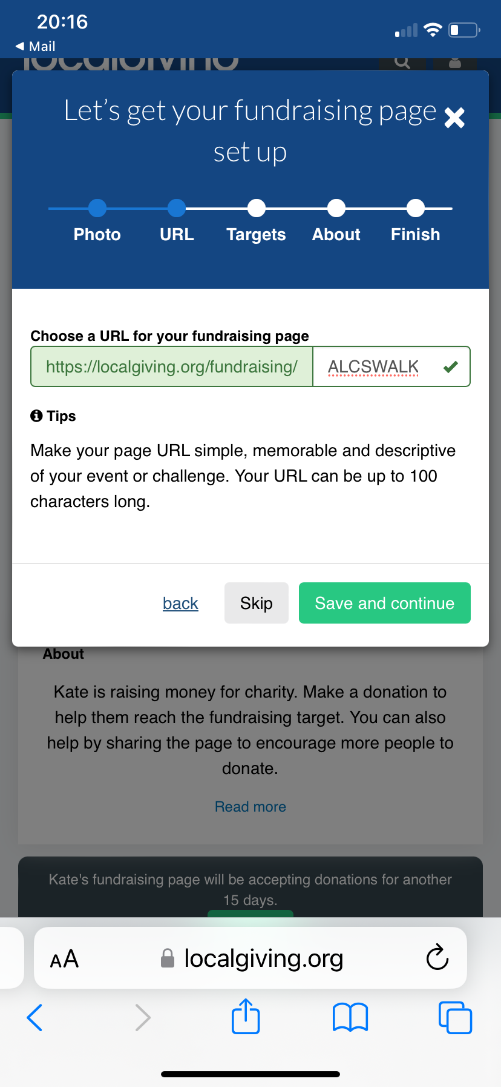
Set your target fundraising amount.  Be realistic about how much you hope to raise.  You can add amounts raised outside localgiving, for example cash donations, to your total. | 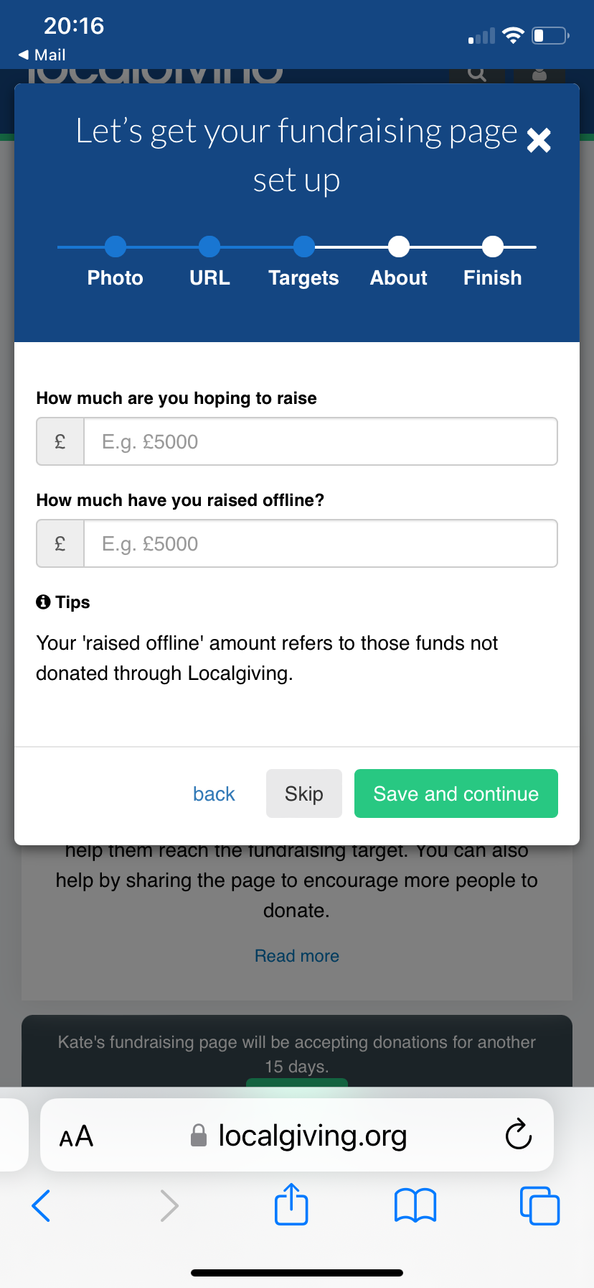
Your event … write a description of what you are doing and why.  Make it personal and describe why you want to raise funds for Axminster and Lyme Cancer Support. | 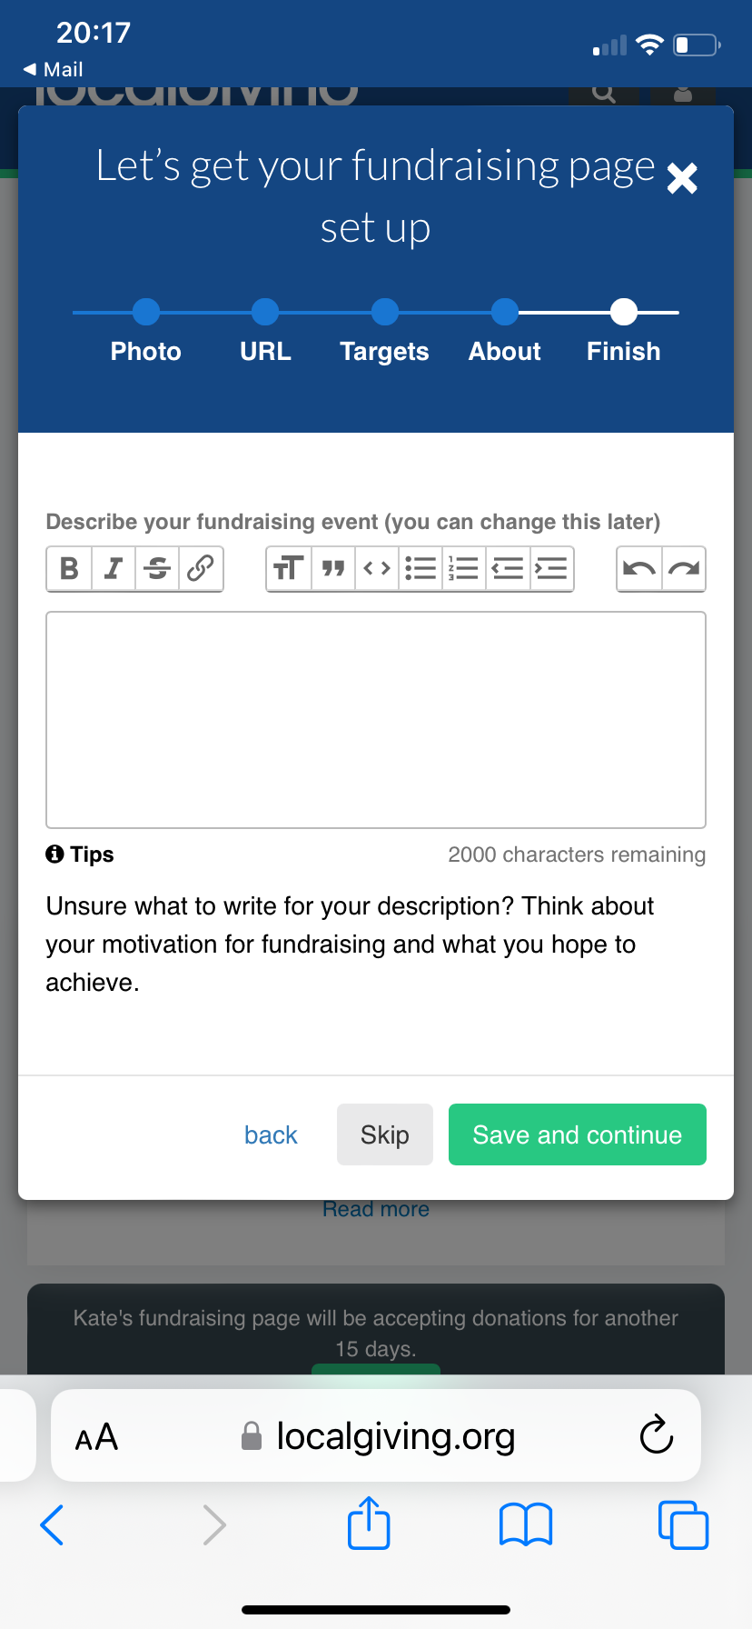
All done!
Share your page with friends/family and on social media if desired.
Remember to tag Axminster and Lyme Cancer Support in any social posts and we will share too!
Thank you for using Local Giving they are the platform that take the least commission so more money comes to ALCS.
Good luck with your fundraising and thank you.

