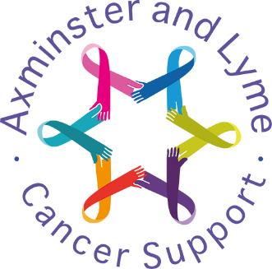

**Food Safety Policy**

Adopted by Trustees on 13th May 2020

Next Review on 11th November 2024

**Key contact: Mary Kahn**

**Axminster and Lyme Cancer Support Charity**

**Registered Charity No 1182035**

# Axminster and Lyme Cancer Support (ALCS)

We provide regular drop-in support sessions for our clients, various workshops and occasional light lunches. We occasionally use external catering companies for events.

# Food Preparation

ALCS will endeavour to make sure foods are properly labelled with instructions such as use-by dates, allergen information and storage guidelines.

When preparing food, ALCS will be mindful the consider the 4 key safety issues of cleaning, cooking, chilling, and avoid cross-contamination.

# Storage

It’s very important to store food properly to keep it safe. ALCS will endeavour to store food in sealed containers, labelled clearly and at the correct temperature to avoid crosscontamination.

**Cleaning**

# ALCS will: -

Advise volunteers to wash their hands regularly with soap and water. Always wash fresh fruit and vegetables before cooking or consumption

Keep raw and ready-to-eat foods separate.

Will not use food past its use-by date

Always follow cooking instructions

Make sure food is properly prepared and cooked before it is served.

Ensure that food preparation areas are suitably cleaned and sanitised after use and wash any equipment being used in hot soapy water.

Ensure frozen food is safely defrosted in a fridge before use.

Keep food out of the fridge for the shortest time possible.

# Food temperature

Food that needs to be chilled, such as sandwiches should be left out of the fridge for the minimum possible time, and never for more than four hours.

After this time, any remaining food will be thrown away.

**Sell By Dates**

ALCS will not sell food or redistributed or consumed after the use-by date.

# Best Before Dates

Food with a best before date can be legally sold, redistributed, and consumed after this date, if judged to be of sufficient quality to be donated and made available to be eaten.

This should include a visual inspection, checking for freshness and any damage. In some instances, torn or damaged outer packaging may be acceptable if the integrity of the primary pack is maintained.

# Allergens

ALCS will provide details of the relevant 14 allergens as best practice to allow people with food allergies to make safe food choices.

Anyone making or donating foods should label it appropriately:

What the item is.

Date of production.

Details of any allergens.

# Higher Risk Foods

Raw milk

Raw shellfish

Soft cheeses

Pâté

Foods containing raw egg

Cooked sliced meats.

# Risk Assessments

ALCS will follow the Guidance on carrying out risk assessments provided by the Health & Safety Executive (HSE), for food preparation, cooking and service.

All kitchen equipment and crockery will be reviewed annually to ensure meet recommended guidelines.

# Meal Containers

Food in containers will be of food grade standard.

`It is safe to re-use glass and plastic containers, if they are free from chips and cracks.

Containers will be thoroughly cleaned to prevent cross-contamination with germs, allergens and physical contaminants.

https://www.food.gov.uk/safety-hygiene/food-safety-for-community-cooking-and-foodbanks

https://fundraisingexpert.com/food-safety/

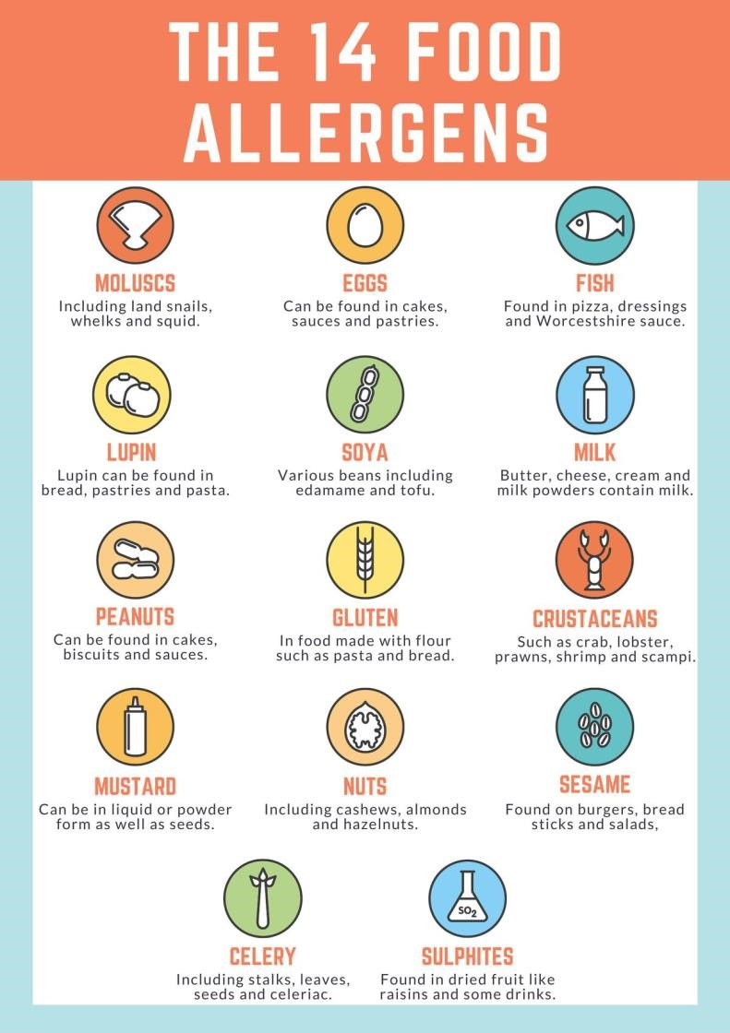

Date of Policy September 2023