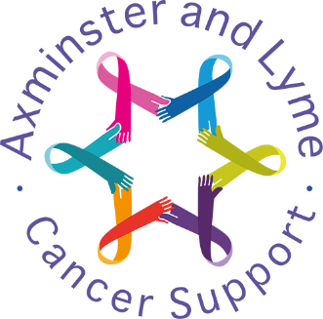

Risk Assessment

Adopted by Trustees on 13th May 2020
Next Review on 11th November 2024

Overview
Axminster and Lyme Cancer Support is required by law to protect employees, volunteers and others from harm.
Under the Management of Health and Safety at Work Regulations 1999, the minimum we must do is:
- identify what could cause injury or illness in our operations (hazards)
- decide how likely it is that someone could be harmed and how seriously (the risk)
- take action to eliminate the hazard, or if this isn’t possible, control the risk

Risk Management
We will take a step-by-step approach to controlling health and safety risks caused by hazards in the course of our activities.
Identifying hazards
We will consider:
- how people use facilities
- what safe or unsafe practices exist
- manual handling
- potential physical hazards
- potential hazards that could lead to stress
- any other perceived hazard
We will consider how each hazard might affect:
- employees
- volunteers
- clients
- members of the public
- any vulnerable person within or using the services of our organisation
We will listen to and act on suggestions from any member of our organisation, our clients or any member of the public who identifies a hazard or how to mitigate it.
Assessing the risks
Once we have identified the hazards, we will decide how likely it is that someone could be harmed and how serious it could be.
We will decide:
- Who might be harmed and how
- What we are already doing to control the risks
- What further action we need to take to control the risks
- Who needs to carry out the action
- When the action is needed by

Controlling the risks
We will do everything ‘reasonably practicable’ to protect people from harm. This means balancing the level of risk against the measures needed to control the real risk in terms of money, time or trouble.
Having identified the hazards and assessed the risks we will:
- eliminate the hazard if at all possible or, where this is not possible,
- control the risk so that harm is unlikely
Recording findings
We will keep records of:
- the hazards (things that may cause harm)
- who might be harmed and how
- what we are doing to control the risks
A risk assessment template can be found at the end of this policy.
Reviewing Controls
We will regularly review any controls we put in place to make sure they are working.
We will also review them if:
- they may no longer be effective
- there are changes that could lead to new risks such as changes to:
  - staff
  - a process or activity
  - venues
We will consider a review if any problems are brought to our attention or there have been any accidents or near misses.
We will update our risk assessment record with any changes we make.

Risk assessment

Company name: Axminster and Lyme Cancer Support

Activity, area or venue being assessed:

Date assessment was carried out: Assessment carried out by:

What are the hazards? | Who might be harmed and how? | What are you already doing to control the risks? | What further action do you need to take to control the risks? | Who needs to carry out the action? | When is the action needed by? | Done

More information on managing risk: www.hse.gov.uk/simple-health-safety/risk/
Template published by the Health and Safety Executive 10/19

