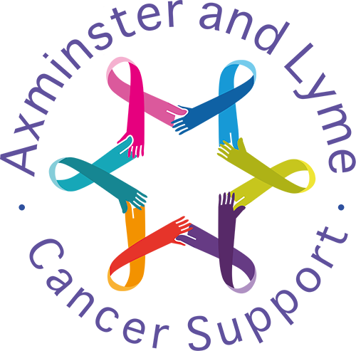
Event overview

Fermented Food Workshop
July - September 2024 – CKH Axminster

Fermented Food Workshops – Sourdough, Sauerkraut, Kefir & Tumeric  Quotes  “Your workshops have helped me incorporate foods into my diet which I previously thought were weird or not for me. And being able to follow up with questions after the workshop was really useful. Thank you for opening my eyes to foods which support my gut health!”  “Extremely useful and very informative. I came away with a lot to think about from the discussions shared at the workshop. I look forward to attending further workshops”.  Testimonials  The events and support offered at ALCS have transformed a very difficult and challenging time in life into a much more manageable and supported experience. I am so grateful for all they offer.  Thanks to  Jane Thomas |  | 15 in attendance over 3 workshops  How likely are you to recommend this event  to another client? 5/5

